GENERATION AND ANALYSIS OF FREQUENCY MODULATED (FM) SIGNALS USING MATLAB
OBJECTIVES:
- To generate a Frequency Modulated (FM) signal using MATLAB by varying the frequency of a high-frequency carrier in accordance with the amplitude of the message signal and to observe the resulting waveform in the time domain.
- To analyze the frequency spectrum of the generated FM signal using FFT and identify the carrier component, sideband frequencies, and the bandwidth of the FM signal based on Carson's rule.

OBJECTIVE 1: To generate a Frequency Modulated (FM) signal using MATLAB by varying the frequency of a high-frequency carrier in accordance with the amplitude of the message signal and to observe the resulting waveform in the time domain.
PROGRAM:
clc;
clear;
close all;

% Parameters
Am = 1;
Ac = 1;
fm = 5;
fc = 50;
beta = 5;
fs = 1000;

% Time vector
t = 0:1/fs:1;

% Message signal
m = Am * cos(2*pi*fm*t);

% Carrier signal
c = Ac * cos(2*pi*fc*t);

% FM signal
fm_sig = Ac * cos(2*pi*fc*t + beta*sin(2*pi*fm*t));

% Plot signals
figure('Name','Frequency Modulation (FM)','NumberTitle','off');

subplot(3,1,1)
plot(t,m)
title('Message Signal')
xlabel('Time (s)')
ylabel('Amplitude')
grid on

subplot(3,1,2)
plot(t,c)
title('Carrier Signal')
xlabel('Time (s)')
ylabel('Amplitude')
grid on

subplot(3,1,3)
plot(t,fm_sig)
title('FM Signal')
xlabel('Time (s)')
ylabel('Amplitude')
grid on

% Display parameters
fprintf('Message Frequency = %d Hz\n', fm);
fprintf('Carrier Frequency = %d Hz\n', fc);
fprintf('Modulation Index (β) = %.2f\n', beta);

OUTPUT:
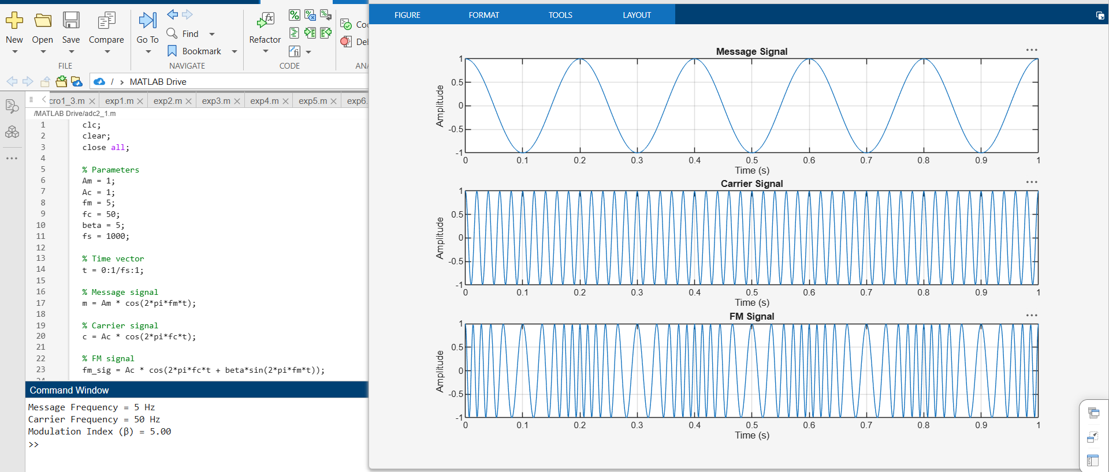

OBJECTIVE 2 : To analyze the frequency spectrum of the generated FM signal using FFT and identify the carrier component, sideband frequencies, and the bandwidth of the FM signal based on Carson's rule.
PROGRAM:
clc;
clear;
close all;

%% Input Parameters
Am = 2; % Message signal amplitude
fm = 500; % Message frequency (Hz)
Ac = 1; % Carrier amplitude
fc = 10000; % Carrier frequency (Hz)
kf = 1000; % Frequency sensitivity (Hz/V)
fs = 100000; % Sampling frequency (Hz)
T = 0.02; % Simulation duration (s)

t = 0:1/fs:T;

%% Message Signal
m = Am * cos(2*pi*fm*t);

%% Frequency Deviation
delta_f = kf * Am;

%% Modulation Index
beta = delta_f / fm;

%% FM Signal
fm_signal = Ac * cos(2*pi*fc*t + beta * sin(2*pi*fm*t));

%% Plot Message and FM Signals
figure;

subplot(2,1,1)
plot(t,m,'LineWidth',1.5)
title('Message Signal')
xlabel('Time (s)')
ylabel('Amplitude')
grid on

subplot(2,1,2)
plot(t,fm_signal,'LineWidth',1.5)
title('Frequency Modulated Signal')
xlabel('Time (s)')
ylabel('Amplitude')
grid on

%% Spectrum Analysis
N = length(fm_signal);
FM_fft = fftshift(abs(fft(fm_signal))/N);
f = (-N/2:N/2-1)*(fs/N);

figure
plot(f,FM_fft,'LineWidth',1.5)
title('FM Signal Spectrum')
xlabel('Frequency (Hz)')
ylabel('Magnitude')
grid on
xlim([fc-10000 fc+10000])

%% Display Results
fprintf('\nFM SIGNAL PARAMETERS\n');
fprintf('---------------------------\n');
fprintf('Carrier Frequency = %.0f Hz\n',fc);
fprintf('Message Frequency = %.0f Hz\n',fm);
fprintf('Message Amplitude = %.2f V\n',Am);
fprintf('Frequency Sensitivity = %.0f Hz/V\n',kf);

fprintf('\nCALCULATED VALUES\n');
fprintf('---------------------------\n');
fprintf('Frequency Deviation (Δf) = %.0f Hz\n',delta_f);
fprintf('Modulation Index (β) = %.2f\n',beta);

%% Carson's Rule Bandwidth
BW = 2 * (delta_f + fm);
fprintf('Bandwidth (Carson Rule) = %.0f Hz\n',BW);

OUTPUT:
